**KEY CONCEPTS REVIEW**

1. What is the meaning of Reiki? __________________________________________________________
2. According to your understanding, how does the Reiki energy circulate? __________________________

____________________________________________________________________________________

1. True or false: Reiki can only bring good energy? _____________________________________________
2. True or false: Reiki energy passes through chakras and meridians? ______________________________
3. 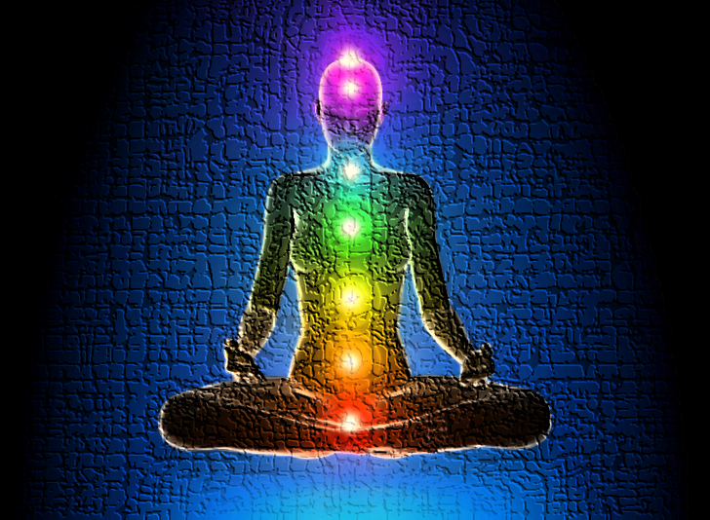Name the 7 basic chakras :

|  |
| --- |
| 7. |
| 6. |
| + |
| 5. |
| 4. |
| 3. |
| 2. |
| 1. |

1. Is Reiki a religious practice? ___________________________________________________________________
2. True or false: it is more important to give Reiki than to receive Reiki? ___________________________________
3. Name 4 essential practises prior to starting a treatment:
4. __________________ 2. __________________ 3.______________________ 4. _____________________
5. Name 3 methods of clearing and protecting the energy before starting a treatment:
6. _________________________ 2. ___________________________ 3. ______________________________
7. Connect the 3 symbols to their Japanese meaning:
8. Power Symbol A) Origin of pure Consciousness
9. Mental Emotional Symbol B) Imperial Seal
10. Distance Symbol C) Creation of new habits